

Software Engineering Department
Braude College of Engineering
Final Project – Phase A (61998)

A Middleware for Automating Customer Interactions on WhatsApp via Workflow-Driven Integration with Business Systems
An Event-Driven, Scalable Middleware for Real-Time Business Automation

By:
Helal Hammoud
Asrar Mghes

Advisor:
Dr. Ze'ev Frenkel

Link to GitHub: https://github.com/helalha7/whatsapp-middleware

Abstract
Customer communication through messaging platforms such as WhatsApp is widely used by small and medium-sized businesses, but is often handled manually, leading to inefficiencies and limited scalability. In addition, these interactions are typically not integrated with backend business systems, creating a gap between communication and operations. This project proposes a middleware platform that connects messaging platforms with business services and transforms customer messages into structured operations. The system supports automated, multi-step interactions while remaining independent of specific business implementations. Overall, it provides a scalable and flexible solution for integrating messaging-based communication with business processes.

Table of Content
1. Introduction 1
1.1 Background and Motivation 1
1.2 Current Approach 1
1.3 The Integration Gap 2
1.4 Problem Formulation 2
1.5 Proposed Solution 3
2. Background and Literature Review 4
2.1 Messaging Platforms and WhatsApp Business API 4
2.2 Chatbot Systems 4
2.3 Workflow-Driven Interaction 5
2.4 Event-Driven Architecture 5
2.5 System Integration and Middleware 5
2.6 Limitations of Existing Approaches 6
3. Product 7
3.1 Product Overview 7
3.2 Target Customers 9
3.3 Product Capabilities 9
3.4 Product Value 10
3.5 Product Limitations / First Version Boundaries 11
3.6 Algorithms 12
3.6.1 Incoming Message Handling Algorithm 12
3.6.2 Workflow Processing Algorithm 12
4. Engineering Process 13
4.1 Concept Evolution 13
4.1.1 Evaluation of Alternative System Approaches 13
4.1.2 Selected System Approach: Middleware Architecture 14
4.1.3 Design Decision: Event-Driven Message Processing 15
4.1.4 Design Decision: Workflow-Based Interaction Model 15
4.2 Requirements Analysis 16
4.2.1 Functional Requirements: 16
4.2.2 Non-Functional Requirements: 17
4.3 Use Case Model 18
4.3.1 Actors 18
4.3.2 Use Case Diagram 18
4.4 System Design and Architecture 19
4.5 Component Interaction Flow 20
5. Testing and Evaluation 23
5.1 Testing Strategy 23
5.2 Functional Test Plan 23
5.3 Non-Functional Evaluation 24
5.4 Evaluation Summary 24

1. Introduction

1.1 Background and Motivation
In recent years, messaging platforms such as WhatsApp have become a primary communication channel between businesses and customers, particularly in service-based industries. These platforms enable fast, direct, and convenient interactions, allowing businesses to respond to customer inquiries, provide support, and manage service-related communication in real time. As a result, many businesses increasingly rely on WhatsApp as a central tool for handling customer interactions and maintaining continuous communication [1].
Despite their widespread adoption, messaging platforms do not automatically eliminate the challenges associated with managing customer communication. Many organizations still handle customer interactions manually, as employees read and respond to each message individually. This approach increases workload, slows response times, and raises operational costs, while making it difficult to scale as the volume of customer requests grows [2].
Another major challenge lies in the lack of integration between messaging platforms and internal business systems. In most organizations, business operations are supported by systems such as databases, booking platforms, and customer management systems. However, communication via messaging platforms is often not integrated with these systems. As a result, employees must manually transfer information between communication channels and backend systems, leading to inefficiencies, delays, and increased risk of human error. As demand continues to grow, these limitations reduce the effectiveness and scalability of traditional customer service processes, highlighting the need for more automated and integrated solutions.

1.2 Current Approach
In response to the challenges described above, various approaches have been developed to improve the management of customer communication. A key development in this area is the introduction of messaging platform infrastructures, such as the WhatsApp Business API, which enable businesses to programmatically send and receive messages. This capability allows communication channels to be connected with backend systems and provides the foundation for building automated communication solutions [3].
Building on top of this foundation, businesses have adopted different types of solutions to handle customer interactions more efficiently. These include chatbot-based systems, automated response mechanisms, and custom integrations with backend services. Such solutions aim to reduce manual workload, improve response times, and support handling multiple customer requests simultaneously [4], [5].

1.3 The Integration Gap
Despite the availability of messaging platforms and automation solutions, a significant gap still exists between customer communication channels and internal business systems. Current approaches often focus on enabling communication or automating responses, but they do not provide a unified and structured way to connect messaging interactions with business operations [8], [9].
In practice, integrations between messaging platforms and backend systems are often implemented as custom, tightly coupled solutions that are specific to each business. This makes them difficult to reuse, extend, or maintain, especially as system complexity grows. As a result, customer interactions remain loosely connected to business processes, limiting the ability to automate complex, multi-step operations such as bookings, service workflows, or data-driven actions [10].
Furthermore, existing solutions often lack a generalized architecture that can support multiple businesses in a scalable and flexible manner. Instead of providing a reusable integration layer, they require each organization to develop and manage its own communication logic, leading to duplicated effort and inconsistent implementations. This gap highlights the absence of a dedicated middleware layer that can bridge messaging platforms and business systems in a structured, scalable, and reusable way, enabling seamless integration between customer interactions and backend operations.

1.4 Problem Formulation
The broad challenge identified in the previous sub-section is the weak integration between messaging platforms and backend business systems. This project focuses on a specific form of this challenge: the absence of a reusable middleware layer that connects WhatsApp-based customer communication with business operations managed by backend systems. In many businesses, WhatsApp is used as a main communication channel, while actual business operations are handled in separate systems such as booking platforms, customer databases, or service management tools. Although these systems may expose APIs, the communication layer and the business operation layer are often connected through custom, business-specific integrations. This creates duplicated development effort, tight coupling, and limited reusability.
The problem addressed by this project is therefore the lack of a generalized middleware mechanism that can receive customer communication from WhatsApp, normalize it into a platform-independent form, coordinate its processing, and connect it with backend business services in a reusable and scalable way. Our project focuses on structured, service-oriented business interactions, such as bookings, service inquiries, support requests, and data retrieval. It does not aim to replace the business’s backend systems, become a full CRM or ERP platform, or solve all forms of open-ended customer communication.

1.5 Proposed Solution
To address the problem defined above, this project proposes a middleware platform that connects WhatsApp-based customer communication with backend business systems. The proposed system acts as an intermediary layer between the messaging channel and business services, allowing businesses to handle customer interactions without building a separate custom integration for each use case.
At a high level, the system receives customer messages from WhatsApp, converts platform-specific message data into a unified internal representation, coordinates the processing of the interaction, and connects the request with the appropriate backend business service. After the business operation is handled, the system sends the relevant response back to the customer through WhatsApp.
The proposed middleware is designed to support structured, service-oriented interactions such as appointment booking, service inquiries, support requests, and data retrieval. By separating communication handling from business-specific backend logic, the solution provides a reusable and scalable foundation that can be adapted to different business domains and service scenarios.
The system is built using a set of established technologies, methods, and development tools. The WhatsApp Business API serves as the primary communication channel, enabling the reception of customer messages and the delivery of automated responses. Incoming messages are received through webhooks and processed asynchronously using message queues and background workers, following an event-driven architecture. Conversation state, workflow data, and interaction logs are stored in a MySQL relational database, while communication with external business systems is performed through REST APIs.
The platform applies workflow-based interaction management to support multi-step customer interactions, including appointment booking, service inquiries, request status checks, and human support requests. Event-driven processing and asynchronous message handling improve system scalability, responsiveness, and reliability while allowing multiple customer interactions to be processed concurrently.
Google Gemini will be used for intent classification. It was selected because it can return structured classification results that can be directly mapped to the system’s predefined interaction templates. This allows the middleware to reliably select the correct workflow and continue the customer interaction without developing a language model from scratch.
The middleware will be implemented primarily using Go and Python as the main programming languages. Visual Studio Code will be used as the primary development environment, while Git will be used for source code version control.

2. Background and Literature Review
This section presents the key concepts and technologies related to the proposed system and reviews existing research in the field. It introduces messaging platforms, chatbot systems, workflow-driven interaction models, event-driven architectures, and system integration approaches, while highlighting their roles in modern business communication. In addition, it examines findings from the literature to provide context and identify the limitations of current solutions.

2.1 Messaging Platforms and WhatsApp Business API
Messaging platforms are widely used digital communication systems that enable real-time interaction between users through text, media, and other forms of messaging. In recent years, these platforms have become a primary channel for business-to-customer communication, allowing organizations to engage with customers in a direct and convenient manner. Studies indicate that messaging platforms improve response times, enhance customer engagement, and support handling multiple interactions simultaneously, making them a preferred communication medium across various industries [3][5][10].
One of the most prominent solutions in this domain is the WhatsApp Business API, which enables businesses to communicate with customers programmatically. Unlike standard messaging applications designed for personal use, this API allows organizations to send and receive messages through backend systems, enabling automation and integration with existing services. The API operates primarily through a webhook-based mechanism, where incoming messages are delivered as HTTP requests, while outgoing messages are sent through API calls. This model provides the foundation for building automated communication systems and integrating messaging platforms with business operations [3][6][10].

2.2 Chatbot Systems
Chatbot systems are software applications designed to automate conversations with users through messaging platforms. They process user inputs and generate responses using predefined rules or artificial intelligence techniques such as natural language processing (NLP). In business environments, chatbots are widely used to handle customer interactions automatically, including answering frequently asked questions and supporting basic service-related tasks [2][4][10].
Research shows that chatbot systems improve customer service by providing instant responses, reducing the workload on human agents, and enabling continuous availability [1][6][10]. In addition, chatbot technologies range from rule-based systems, which rely on predefined logic, to more advanced AI-based systems capable of handling flexible and context-aware interactions [2][7][9][10].

2.3 Workflow-Driven Interaction
Workflow-driven interaction refers to a structured approach for managing user interactions by organizing them into a sequence of steps. Instead of treating each message as an isolated request, the system handles interactions as part of a continuous process, where each step depends on the previous one. This approach enables the system to guide users through multi-step tasks such as service booking or information retrieval [10][9].
In this model, user input is interpreted based on the current state of the interaction, and the system determines the next action accordingly. This allows for more consistent and organized handling of complex interactions, particularly when multiple pieces of information are required to complete a task. Studies suggest that workflow-based interaction models improve the management of structured processes, enhance customer interaction efficiency, and provide better alignment with business operations [9][10][8].

2.4 Event-Driven Architecture
Event-driven architecture is a design approach in which system components communicate by producing and consuming events. An event represents a change or action in the system, such as receiving a message from a user. Instead of processing requests synchronously, events are handled asynchronously, allowing the system to respond without blocking other operations [7][10].
In this model, events are typically placed in a queue or message broker and processed by background workers. This enables the system to handle multiple events concurrently, improving scalability and responsiveness. Event-driven architectures are widely used in systems that require high availability and efficient processing of large volumes of data [7][9][10].
By decoupling event producers from consumers, this approach increases system flexibility and allows components to evolve independently, making it suitable for complex and scalable applications [9][10].

2.5 System Integration and Middleware
System integration refers to the process of connecting different software systems so they can communicate and exchange data effectively. It enables multiple applications to operate as a unified system by coordinating data flow and interactions between components [3][9][10].
Middleware is a software layer that sits between systems and facilitates this integration. It acts as an intermediary that manages communication, data transformation, and coordination between different services. Research highlights that middleware-based approaches improve modularity, flexibility, and maintainability, making them suitable for integrating heterogeneous systems in scalable environments [7][9][10].

2.6 Limitations of Existing Approaches
Despite the advancements in messaging platforms, chatbot systems, and integration technologies, the literature consistently identifies several important limitations. A major challenge is the lack of seamless integration between communication platforms and backend business systems, which leads to fragmented workflows and inefficient data handling [3][7][9][10].
Additionally, many existing solutions are primarily designed to handle simple or predefined interactions and struggle to support complex, multi-step processes that require coordination with backend services [2][5][9][10]. This limits their ability to fully automate real business operations.
Another key limitation is scalability and generalization. Many implementations are developed as custom, tightly coupled solutions tailored to specific organizations, making them difficult to reuse, extend, or adapt across different business environments [6][7][10].
Finally, the lack of structured workflow management further reduces the effectiveness of current systems, as interactions are often treated as isolated messages rather than as part of continuous processes. This highlights the need for approaches that can support stateful, workflow-driven interaction models and better integration with business operations [9][10].

3. Product
This section presents the proposed system as a product. It describes the platform’s purpose, the types of businesses it targets, the main capabilities it provides, and the product scope. Unlike the engineering process and architecture sections, this section focuses on the product from a practical and business-facing perspective rather than on its internal technical implementation.

3.1 Product Overview
The proposed product is a middleware platform that connects WhatsApp customer communication with existing business backend systems. It allows businesses to receive customer requests through WhatsApp, identify the relevant interaction type, collect the required information, and execute a configured backend operation.
The product supports a limited set of predefined interaction templates rather than fully custom workflows. The supported templates are: (i) Appointment Booking, (ii) Service Inquiry, (iii) Request Status Check, (iv) Human Support Request. Each template can be connected to a backend operation defined by the business. A backend operation includes both the business meaning of the operation and the technical execution details, such as the operation name, required input fields, backend API endpoint, HTTP method, and request mapping. This means that an operation combines what it means from the business perspective with how it is executed technically.
Figure 1 shows an example of the backend operation configuration screen. In this example, the predefined templates are listed as configurable business operations. For each template, the business can define or review the operation name, backend API endpoint, HTTP method, and field mapping. For example, the Appointment Booking template is connected to a POST endpoint for creating appointments, while the Request Status Check template is connected to a GET endpoint for retrieving the status of an existing request.
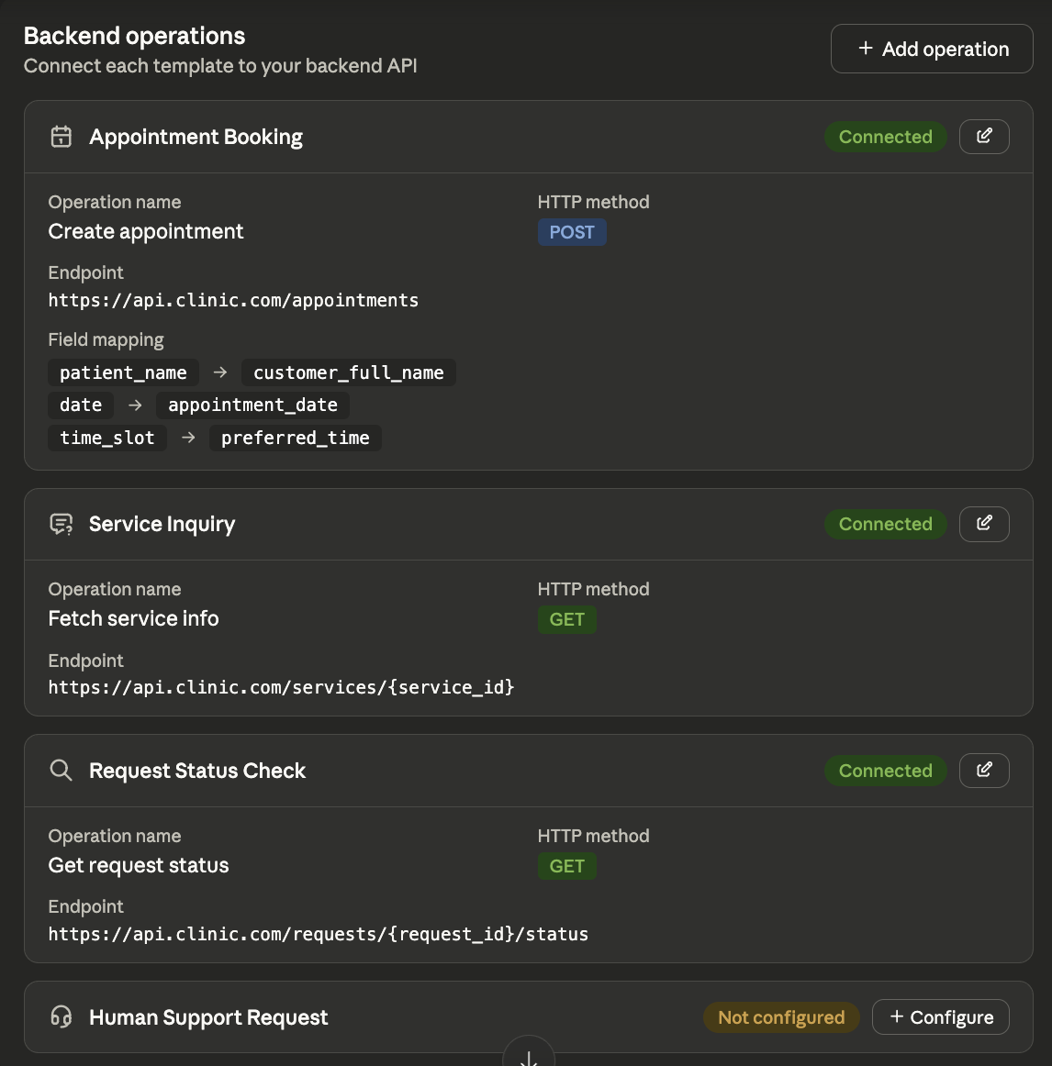
Fig. 1: Backend Operation Configuration Screen
The product does not replace the business’s backend system or act as the main source of business data. Instead, it provides a reusable connection layer that allows WhatsApp messages to trigger structured backend operations without building a separate WhatsApp integration for every business case.
The product also provides a business-facing monitoring dashboard for tracking customer interactions handled by the middleware. Figure 2 shows an example of this dashboard. It presents summary metrics such as the total number of interactions, completed interactions, interactions in progress, and failed interactions. It also displays recent customer interactions with details such as the customer name, selected interaction template, time, and current status. This helps the business monitor WhatsApp-based requests, identify failed interactions, and follow interactions that are still in progress.
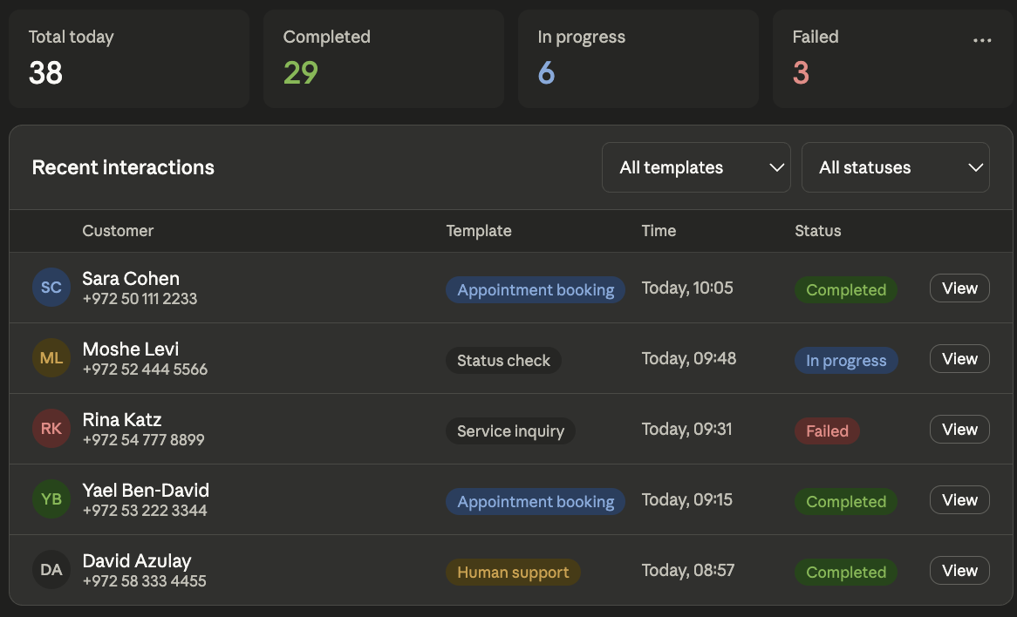
Fig. 2: Business Interaction Monitoring Dashboard

3.2 Target Customers
The product is intended for small and medium-sized service-based businesses that use WhatsApp as a main customer communication channel while managing their operations through existing backend systems. These businesses usually face a gap between communication and execution: customer requests arrive through WhatsApp, but the actual operations are handled in booking platforms, customer databases, service management tools, or internal applications.
The product is most suitable for businesses that receive repeated customer requests, already manage their operations digitally, and can map their WhatsApp interactions to predefined templates such as Appointment Booking, Service Inquiry, Request Status Check, or Human Support Request. Examples of suitable businesses include private clinics, training centers, beauty and wellness businesses, repair services, and local appointment-based service providers.
The product is not intended to replace existing backend systems, provide a full CRM, or handle completely open-ended conversations. Instead, it focuses on structured, repeated interactions that can be connected to backend operations.

3.3 Product Capabilities
The first version of the product provides a focused set of capabilities that allow WhatsApp customer interactions to be connected to backend business operations.
The product supports the following main capabilities:
- WhatsApp-to-backend connection
The product connects customer requests received through WhatsApp with existing business systems such as booking platforms, customer databases, service management tools, or internal applications.
- Predefined interaction templates
The product supports a limited set of predefined interaction templates: Appointment Booking, Service Inquiry, Request Status Check, and Human Support Request.
- Backend operation configuration
Each interaction template can be connected to a backend operation configured by the business. The configuration includes the operation name, required input fields, API endpoint, HTTP method, and field mapping.
- Conversation-based data collection
The product collects the required information from the customer across one or more WhatsApp messages before executing the backend operation.
- Backend operation execution
After the required information is collected, the product calls the configured backend API to perform the relevant business action, such as creating an appointment or checking the status of a request.
- WhatsApp response handling
The product sends a response back to the customer through WhatsApp based on the result of the backend operation.
- Conversation progress tracking
The product maintains the progress of multi-message interactions until the interaction is completed, fails, or requires human support.
- Human support identification
The product can identify interactions that cannot be completed automatically and mark them as requiring human support.
- Basic interaction tracking
The product provides basic tracking of handled interactions, including completed operations, failed operations, and interactions transferred to human support.

3.4 Product Value
The product provides value by simplifying the connection between WhatsApp customer communication and existing business backend systems. Instead of requiring each business to build a custom WhatsApp integration, the platform provides a reusable structure for mapping common WhatsApp interactions to configured backend operations.
The main value of the product is that it connects communication with real business execution. Customer requests received through WhatsApp can trigger operations in existing systems such as booking platforms, customer databases, service management tools, or internal applications. This reduces the gap between receiving a message and performing the required business action.
The product also reduces manual handling of repeated requests by supporting predefined interaction templates such as appointment booking, service inquiries, request status checks, and human support requests. These templates help businesses handle common requests more consistently while keeping their existing backend systems as the source of truth.
Another important value is reusability. The same product structure can serve different businesses because the supported interaction templates remain common, while the backend operation configuration can be adjusted according to each business system.
Finally, the product supports gradual automation. It does not require full automation of all customer conversations. Instead, it focuses on structured and repeated interactions, while cases that cannot be handled automatically can be marked for human support.

3.5 Product Limitations / First Version Boundaries
The first version of the product is limited to connecting WhatsApp customer communication with existing backend systems through predefined interaction templates. It does not provide a fully custom workflow builder, a general-purpose chatbot, or a replacement for the business’s existing backend system. The product focuses only on structured and repeated interactions that can be mapped to supported templates such as appointment booking, service inquiry, request status checking, and human support requests.
The product also assumes that backend systems can be connected through configured API operations. More complex integration methods, advanced analytics, support for multiple communication channels, and fully open-ended conversation handling are outside the scope of the first version.

3.6 Algorithms
This section describes the main processing algorithms used by the proposed product. The system does not rely on complex mathematical algorithms. Instead, it uses event-driven processing, workflow management, and backend operation execution to transform WhatsApp messages into structured business actions.

3.6.1 Incoming Message Handling Algorithm
This algorithm is responsible for receiving incoming WhatsApp messages and converting them into internal events for asynchronous processing.
- Receive a webhook request from the WhatsApp Business API.
- Validate the incoming payload.
- If the payload is invalid:
  - Reject the request.
  - Log the validation error.
- If the payload is valid:
  - Extract message data.
  - Convert the message into an internal inbound event.
  - Store and enqueue the event.
- Return a fast acknowledgment to WhatsApp.
- Continue processing asynchronously through background workers.

3.6.2 Workflow Processing Algorithm
This algorithm processes queued events and manages customer interactions.
- A worker consumes an inbound message event.
- Log the event for monitoring and tracking purposes.
- Dispatch the event to the Application Layer.
- Load or create the conversation state.
- Check whether a workflow is already running.
- If no workflow exists:
  - Identify the message intent.
  - Select the appropriate workflow template.
  - Start a new workflow.
- Otherwise:
  - Continue the existing workflow.
  - Update workflow progress.
- Check whether all required data has been collected.
- If information is missing:
  - Generate the next question.
  - Send a response to the customer.
- If all required data is available:
  - Execute the business operation.
  - Generate the final response.
  - Create an outbound message request.
  - Enqueue an outbound message event.

4. Engineering Process

4.1 Concept Evolution
The design of the proposed system evolved through a gradual analysis of the challenges associated with customer communication through messaging platforms. The following subsections describe the key stages in the evolution of the system concept and the reasoning behind the main design decisions.

4.1.1 Evaluation of Alternative System Approaches
At the beginning of the design process, multiple approaches were considered for solving the problem of automating customer communication through WhatsApp. The first approach was to use a chatbot-based solution. This approach appeared useful because chatbots can automate simple customer replies, reduce manual workload, and improve response time. However, a chatbot alone does not define how customer messages are reliably connected to backend business operations. In particular, chatbot-based systems may handle conversation flow, but they do not necessarily provide a reusable architecture for mapping different customer requests to different business APIs across multiple organizations.
The second approach was direct integration between WhatsApp and the business backend system. In this model, incoming WhatsApp messages could directly trigger API calls in the business system. This approach provides a simple integration path for one specific business case. However, it creates tightly coupled implementations, where each business requires custom message parsing, custom API handling, and custom response logic. As a result, this approach is difficult to generalize, reuse, and maintain when supporting multiple businesses with different workflows and backend systems.
The third approach was to introduce a middleware architecture between WhatsApp and business backend systems. In this approach, the middleware is responsible for receiving messages, normalizing them into an internal representation, managing the processing flow, and connecting them to configured business operations. This approach adds architectural complexity, but it provides a more reusable and extensible foundation for supporting multiple businesses.

Decision | Limitations | Advantage | Approach
Not selected as the main system approach | Does not provide a structured and reusable way to connect conversations with backend business operations | Can automate simple customer replies and reduce manual response workload | Chatbot-based solution
Not selected as the main system approach | Creates business-specific, tightly coupled implementations that are difficult to reuse across multiple businesses | Allows WhatsApp messages to trigger backend API operations directly | Direct integration
Selected as the main system approach | Requires additional design for event handling, workflow management, and operation configuration | Decouples messaging platforms from business systems and provides a reusable integration | Middleware architecture

4.1.2 Selected System Approach: Middleware Architecture
Based on the comparison of alternative approaches, the middleware architecture was selected as the main system approach. The purpose of the middleware is to act as an intermediary layer between WhatsApp as a customer communication channel and the backend systems used by businesses.
This decision was made because the system is intended to support more than one business and more than one type of business operation. A direct integration approach would require each business case to be implemented separately, while a middleware approach allows common communication and processing mechanisms to be reused. The middleware can receive platform-specific messages, transform them into a unified internal event format, and pass them to the application logic without exposing the application layer directly to WhatsApp’s payload structure.
This separation improves maintainability because changes in the WhatsApp communication layer do not necessarily require changes in the business workflow logic. It also improves extensibility because new business operations can be added through configuration and application-level processing without redesigning the message reception mechanism.

4.1.3 Design Decision: Event-Driven Message Processing
After selecting the middleware approach, the next design concern was how incoming messages should be processed. A synchronous processing model was considered unsuitable because it would require the webhook request to remain active while the system performs business-level processing, such as intent recognition, workflow progression, external API calls, and response generation. This creates a risk that slow business APIs or long-running workflows delay the webhook response. It also couples message reception with application-level processing, making the system less responsive under load. Therefore, an event-driven processing model was adopted.
In this model, incoming WhatsApp payloads are validated, transformed into internal events, stored, and queued for asynchronous processing. The webhook handler is responsible only for receiving and preparing the event, while background workers are responsible for processing queued events independently. This design separates message reception from business processing, improves responsiveness, and allows the system to process multiple conversations concurrently.

4.1.4 Design Decision: Workflow-Based Interaction Model
The final major design decision was the adoption of a workflow-based interaction model. Customer communication through WhatsApp is not always a single-message interaction. Many business operations require multiple steps, such as collecting customer details, confirming choices, checking availability, executing an operation, and returning the final result.
Treating each message as an isolated request would make it difficult to support these scenarios because the system would not know what information has already been collected or what step the customer is currently in. Therefore, the application layer was designed to manage conversations as workflows.
In this model, each workflow represents a structured sequence of steps required to complete a business operation. The system maintains conversation state across messages, including the current workflow, the current step, collected input fields, and pending operations. This allows the system to guide the customer through multi-step processes in a consistent and controlled manner.

4.2 Requirements Analysis
The system requirements are divided into functional requirements, which describe the system’s supported capabilities, and non-functional requirements, which define its expected quality attributes and operational characteristics.

4.2.1 Functional Requirements:
FR-1. WhatsApp API Integration
The Infrastructure Layer shall support integration with the WhatsApp Business API for receiving incoming messages and events.
FR-2. Unified Event Representation
The Infrastructure Layer shall support a unified internal representation of incoming messages and events.
FR-3. Outbound Response Support
The Infrastructure Layer shall support automated outbound responses through the WhatsApp Business API.
FR-4. Interaction Logging
The Infrastructure Layer shall support logging of customer interactions and system activities.
FR-5. Conversation State Management
The Application Layer shall manage customer conversation state across multiple interactions.
FR-6. Intent Identification
The Application Layer shall support identification of customer interaction intent.
FR-7. Workflow Management
The Application Layer shall support workflow-based customer interaction management.
FR-8. Business Operation Execution
The Application Layer shall support execution of business operations through external backend services.
FR-9. Customer Response Generation
The Application Layer shall generate responses based on interaction progress and business operation results.
FR-10. Appointment Booking Support
The Application Layer shall support appointment booking interactions through WhatsApp communication.
FR-11. Service Inquiry Support
The Application Layer shall support customer service inquiry interactions.
FR-12. Request Status Support
The Application Layer shall support customer request status checking interactions.
FR-13. Human Assistance Request Support
The Application Layer shall support customer requests for human assistance.
FR-14. Workflow Configuration
The Application Layer shall support configuration and management of communication workflows.
FR-15. Backend Integration Configuration
The Application Layer shall support configuration of backend business API integrations.

4.2.2 Non-Functional Requirements:
NFR-1. Scalability
The system shall support the concurrent processing of multiple customer interactions without significant degradation in response time.
NFR-2. Reliability
The system shall ensure reliable processing and delivery of customer interactions.
NFR-3. Maintainability
The system shall maintain separation between communication handling and business logic components to support easier maintenance and modification.
NFR-4. Extensibility
The system shall allow the addition and configuration of new workflows and backend integrations without requiring major modifications to the system architecture.
NFR-5. Availability
The system shall remain operational and available for receiving and processing customer interactions during normal system operation.

4.3 Use Case Model

4.3.1 Actors
The product includes 2 main actors :
Actor | Description
Customer | A person who communicates with the business through WhatsApp in order to complete one of the supported customer interactions, such as appointment booking, service inquiry, request status check, or human support request.
Business Manager | A business representative who configures how the business uses the platform. The Business Manager selects supported customer interaction templates, configures service operations, connects backend services, and reviews customer conversations.
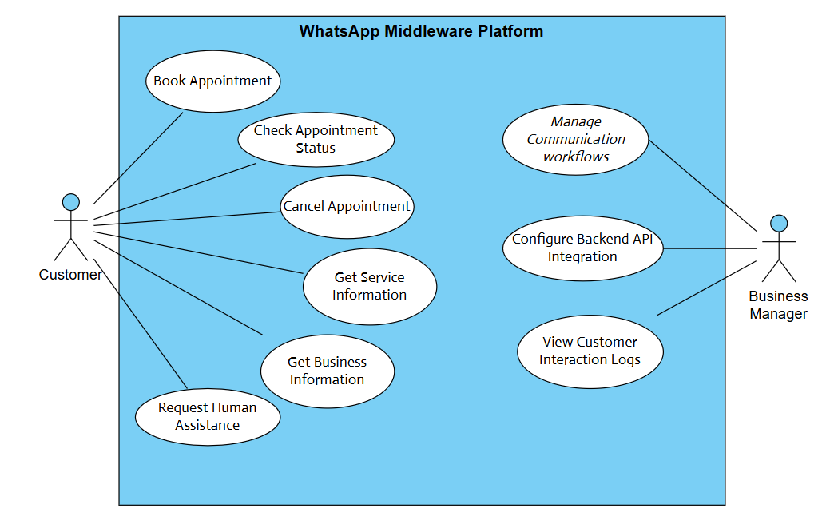

4.3.2 Use Case Diagram

Fig 4: Use Case Diagram

4.4 System Design and Architecture
The proposed system is designed as a client-server middleware system. At the system boundary, external systems communicate with the middleware through network-based interfaces. The WhatsApp Business API sends incoming message payloads to the middleware through webhook calls, while the middleware sends outgoing messages back through the WhatsApp Business API. The web dashboard also communicates with the middleware through HTTP requests in order to manage configuration, registration, and logs.
Inside the server-side middleware, the system is organized using a layered architecture. The two main layers are the Infrastructure Layer and the Application Layer. The purpose of this separation is to keep platform-level communication and event-processing concerns separate from application logic, conversation handling, workflow execution, and business-operation execution.
- The Infrastructure Layer is responsible for receiving WhatsApp payloads, validating them, transforming them into internal events, storing and queueing these events, and processing them asynchronously using workers. This layer follows an event-driven architecture because incoming messages are treated as events that can be stored, queued, and processed independently from the original webhook request.
- The Application Layer is responsible for handling the meaning and progress of customer interactions. It receives internal events from the Infrastructure Layer, resolves the intended interaction, manages conversation context, executes the relevant workflow, calls configured backend operations through the Business API Client, and generates the response that should be sent back through WhatsApp. Internally, this layer is organized using a Controller-Service-Repository structure, where controllers and boundaries receive requests or internal events, services coordinate application logic, and repositories handle access to persistent data.
The system also includes external integration points. The NLP service may be used by the Application Layer to support intent resolution, while the business backend system is called when a configured business operation must be executed. The middleware database is used to persist system data such as events, configuration, conversation context, logs, and operation results.
Overall, the architecture combines a client-server model at the system boundary, a layered architecture inside the middleware, an event-driven architecture in the Infrastructure Layer, and a Controller-Service-Repository structure in the Application Layer.
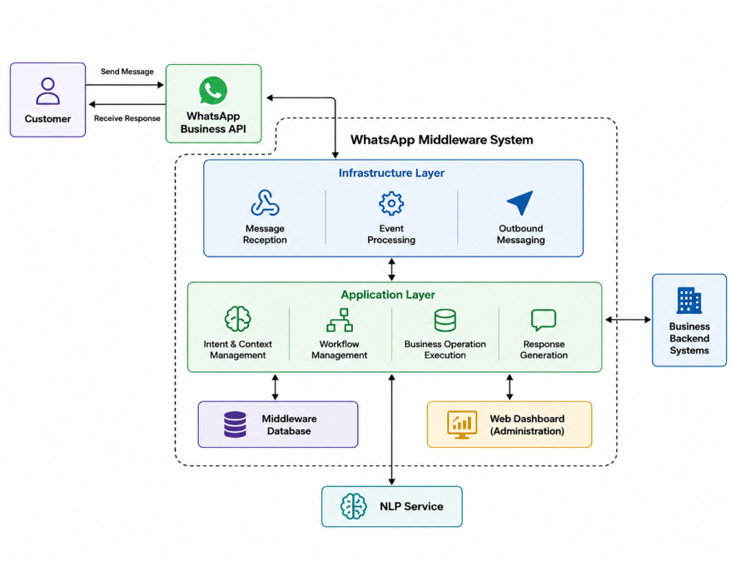
Fig 5: High-Level System Architecture Diagram

4.5 Component Interaction Flow
The interaction between the system components follows an asynchronous event-based processing flow. When a customer sends a WhatsApp message, the WhatsApp Business API delivers it to the middleware through a webhook request. The Infrastructure Layer validates the payload, extracts the relevant data, converts it into an internal event, stores it, and places it in a queue.
After the event is queued, the system returns a fast acknowledgment to the WhatsApp Business API, while the actual processing continues in the background. A worker retrieves the event and forwards it to the Application Layer, where the conversation state is loaded, the customer intent is handled, and the appropriate workflow step is executed. If needed, the Application Layer calls an external backend API, generates a response, and sends it back to the customer through the Infrastructure Layer.
This separation improves responsiveness and allows multiple customer interactions to be processed asynchronously.
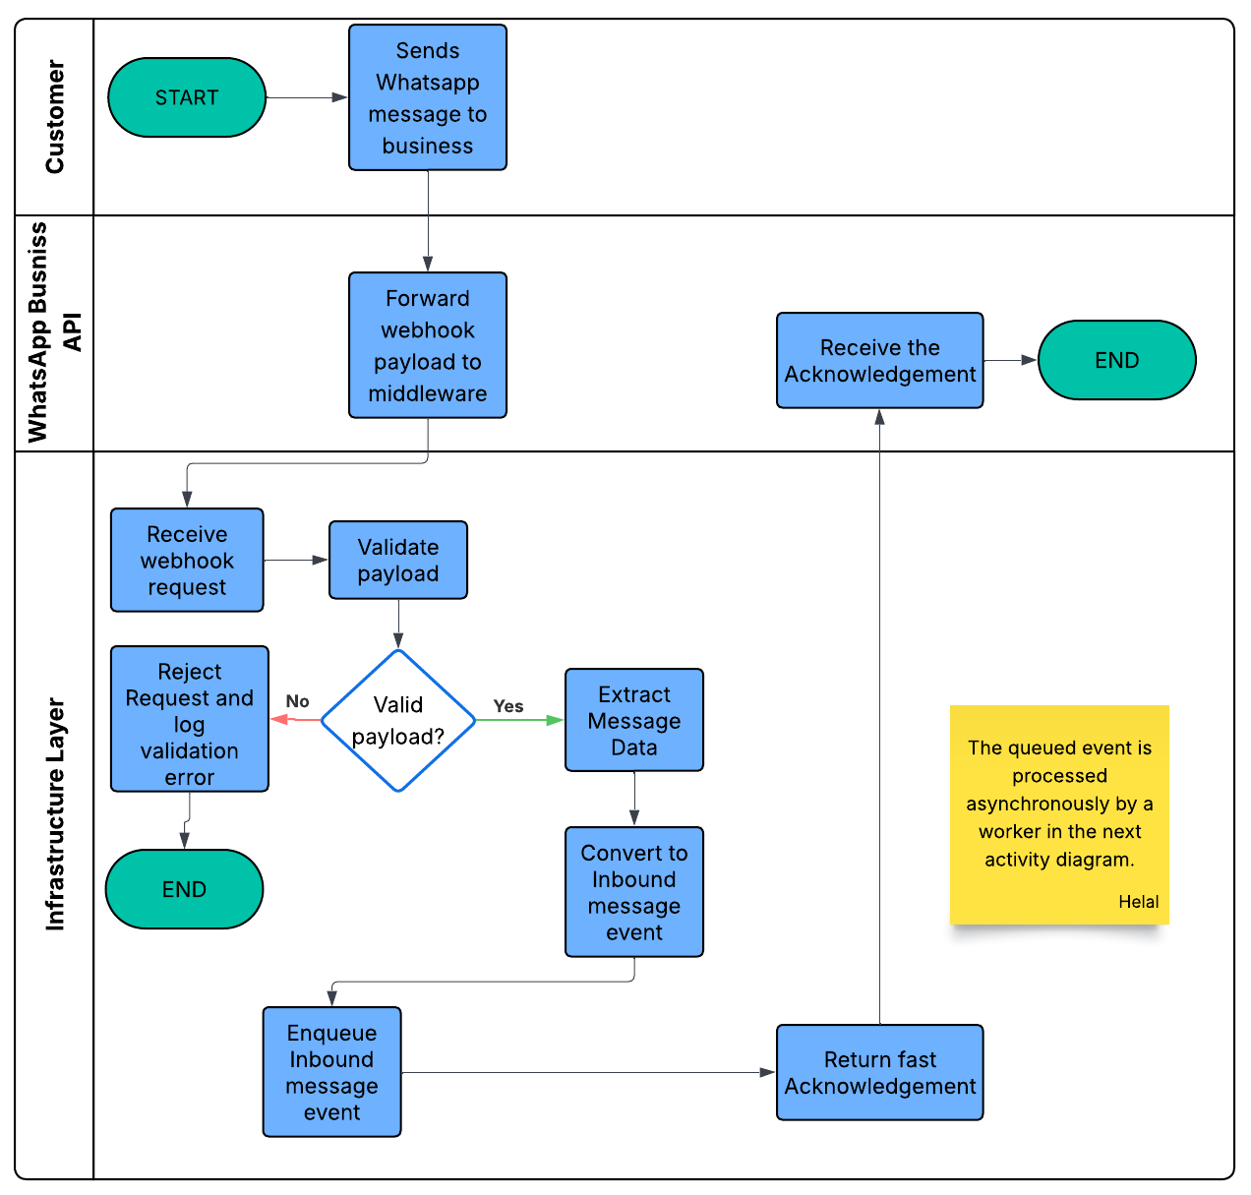
Fig 6: Incoming Message Handling Activity Diagram

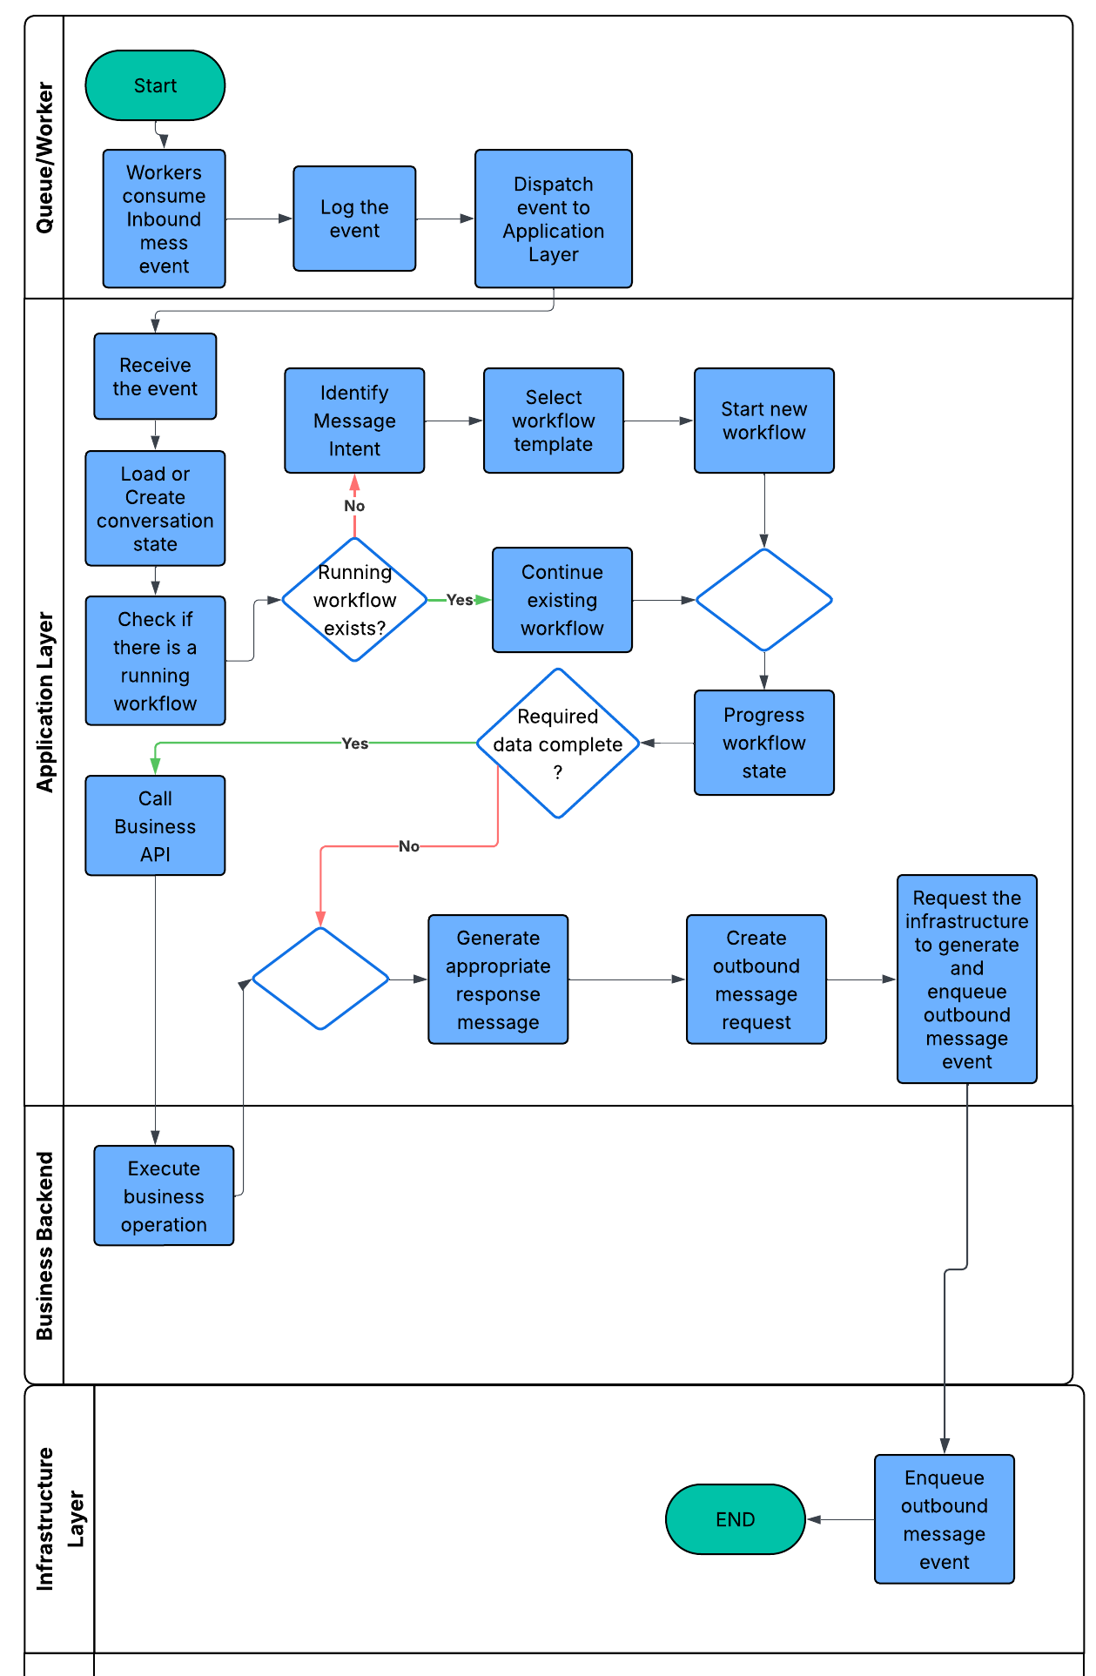
Fig 7: Async Handling For Inbound Message Event Activity Diagram

5. Testing and Evaluation
This section presents the testing and evaluation approach for the proposed system. The evaluation verifies that the system satisfies the functional requirements related to WhatsApp communication, unified event processing, workflow handling, backend operation execution, and customer response generation. It also evaluates the main non-functional requirements: scalability, reliability, maintainability, extensibility, and availability.

5.1 Testing Strategy
The system will be tested using manual scenario testing, API testing, and component-level testing. Manual testing will simulate customer conversations through WhatsApp or mocked messages. API testing will verify webhook handling, outbound responses, and backend operation calls. Component-level testing will validate internal logic such as event creation, conversation state management, intent identification, workflow progression, logging, and response generation.

5.2 Functional Test Plan
Related Requirement | Test Focus | Expected Result
FR-1 | Receive incoming WhatsApp messages and events. | The Infrastructure Layer receives valid webhook requests from the WhatsApp Business API.
FR-2 | Convert incoming messages into a unified internal event format. | Incoming payloads are transformed into internal events containing the required message data.
FR-3 | Send automated outbound responses through WhatsApp. | The Infrastructure Layer sends generated responses through the WhatsApp Business API.
FR-4 | Log customer interactions and system activities. | Important interaction steps, system actions, and errors are recorded.
FR-5 | Manage conversation state across multiple messages. | The system continues the interaction from the correct workflow step.
FR-6, FR-7 | Identify customer intent and manage workflow execution. | The Application Layer selects or continues the appropriate workflow.
FR-8, FR-15 | Execute configured backend business operations. | Completed workflows trigger the correct external backend operation using the configured API details.
FR-9 | Generate customer responses. | The system generates responses according to workflow progress and backend operation results.
FR-10–FR-13 | Support appointment booking, service inquiry, request status checking, and human assistance. | The supported customer interaction templates are handled correctly through WhatsApp.
FR-14 | Configure and manage communication workflows. | Workflow configurations are stored and used during customer interactions.

5.3 Non-Functional Evaluation
Requirement | Evaluation Method | Expected Result
NFR-1 Scalability | Simulate multiple customer interactions arriving close together. | The system processes interactions concurrently using asynchronous queue-based processing.
NFR-2 Reliability | Simulate invalid payloads, backend failures, and processing errors. | The system logs failures and continues handling interactions without losing the flow.
NFR-3 Maintainability | Review the separation between Infrastructure Layer and Application Layer. | Communication handling remains separate from workflow and business logic.
NFR-4 Extensibility | Add or configure a new workflow or backend integration. | The system supports extension without major architectural changes.
NFR-5 Availability | Keep the webhook receiver active while background processing is delayed or failing. | The system remains available for receiving and processing customer interactions.

5.4 Evaluation Summary
The system will be considered successful if it satisfies the defined functional requirements, supports the main WhatsApp customer interaction templates, processes messages asynchronously, executes configured backend operations, and sends appropriate customer responses. The evaluation also verifies that the architecture satisfies the main non-functional requirements while preserving separation between infrastructure concerns and application-level workflow logic.

References
[1]
Ben-Enukora, C., Ejem, A. A., Adeyeye, B. K., Ikunle, O. F., & Maduadichie, F. E. (2022). Awareness, adoption and perception of WhatsApp customer service chatbots in the banking sector: Perspectives from undergraduate students in Lagos, Nigeria. Nigerian Journal of Communication Review, 1(2), 60–70. https://eprints.lmu.edu.ng/id/eprint/5268
[2]
Alia, P. A., Febriana, R. W., Prayogo, J. S., & Kriswibowo, R. (2024). Implementation chatbot on WhatsApp using artificial intelligence with natural language processing method. Electron: Jurnal Ilmiah Teknik Elektro, 5(1), 8–14. https://doi.org/10.33019/electron.v5i1.134
[3]
Ramanuj, N. G. (2025). Impact of WhatsApp Business API on business communication and customer engagement: An examination of Pinggo's implementation. International Journal of Science, Architecture, Technology and Environment. https://doi.org/10.63680/ijsate1025015.018
[4]
Sasmitha, K. P., & Triana, Y. S. (2024). Implementation of WhatsApp chatbot for consumer complaints (Case study: PT. Kipa Teknologi Indonesia). International Journal of Computer Science and Mobile Computing, 13(8), 130–141. https://doi.org/10.47760/IJCSMC.2024.V13I08.014
[5]
Rawal, H., Kothari, P., & Murdia, M. (2025). Analyzing the impact of WhatsApp chatbot on customer experience in the hotel industry: An in-depth review. Journal of Advance and Future Research , 3(8). https://rjwave.org/jaafr/papers/JAAFR2508020.pdf
[6]
Patil, P. M., Kadam, V. J., & Padte, L. (2026). WhatsApp automation and AI agent. International Journal of Advanced Research in Science, Communication and Technology, 6(1). https://ijarsct.co.in/Paper30785.pdf
[7]
Brauer, C., Ponnet, J., & Zehrer, A. (2025). Examining adoption and effectiveness of WhatsApp as a marketing tool: An example of an Austrian fitness and health center. International Journal of Digital Marketing Science, 2(2), 66–86. https://journal.adpebi.com/index.php/ijdms/article/download/1407/1132
[8]
Hari, A., & Abdullah, M. S. (2023). WhatsApp as a superapp: Chatbots, Business API and the challenges ahead (Working Paper No. IIMK/WPS/583/ITS/2023/06). Indian Institute of Management Kozhikode. https://iimk.ac.in/uploads/publications/IIMKWPS583ITS202306.pdf

[9]
Vebrianti, R., Aras, M., Putri, M. S. S., & Swandewi, I. A. (2025). AI chatbots in e-commerce: Enhancing customer engagement, satisfaction and loyalty. Paper Asia, 41(2B), 248–260. https://doi.org/10.59953/paperasia.v41i2b.445
[10]
Mhiribidi, T. C., Chigodo, E. T., & Jowa, V. (2024). Conversational commerce: Designing and evaluating a WhatsApp-based e-commerce chatbot. Proceedings of the 2024 3rd Zimbabwe Conference on Information and Communication Technologies (ZCICT). https://doi.org/10.1109/ZCICT63770.2024.10958353
[11]
Kommera, A. R. (2020). The power of event-driven architecture: Enabling real-time systems and scalable solutions. Turkish Journal of Computer and Mathematics Education, 11(1), 1740–1751. https://doi.org/10.61841/turcomat.v11i1.14928

